**Parent Function Worksheet Name __________________Pd. ___**

**# 1- 7 Give the name of the parent function and describe the transformation represented.**

1. g(x) = x 2 – 1 Name: ___­­­­­­­­­­­­­­­­_________________________

Transformation: ___­­­­­­­­­­­­­­­­_________________________

2. f(x) = - 3 Name: ___­­­­­­­­­­­­­­­­_________________________

Transformations___­­­­­­­­­­­­­­­­_________________________

3. h(x) = - Name: ___­­­­­­­­­­­­­­­­_________________________

Transformations___­­­­­­­­­­­­­­­­_________________________

4. g(x) = -x3+ 3 Name: ___­­­­­­­­­­­­­­­­_________________________

Transformations___­­­­­­­­­­­­­­­­_________________________

5. g(x) = log2(x - 1) Name: ___­­­­­­­­­­­­­­­­_________________________

Transformation___­­­­­­­­­­­­­­­­_________________________

6. f(x) =  - 2 Name: ___­­­­­­­­­­­­­­­­_________________________

Transformations___­­­­­­­­­­­­­­­­_________________________

7. h(x) = log5(x +2) - 3 Name: ___­­­­­­­­­­­­­­­­_________________________

Transformations___­­­­­­­­­­­­­­­­_________________________

**#8-12 Identify the domain and range of the function. Describe the transformation from its parent function.**

8. g(x) =  + 5 Domain : ___­­­­­­­­­­­­­­­­________________ Range : ___­­­­­­­­­­­­­­­­________________

Transformations___­­­­­­­­­­­­­­­­_________________________

9. h(x) = - x2 + 1 Domain : ___­­­­­­­­­­­­­­­­________________ Range : ___­­­­­­­­­­­­­­­­________________

Transformations___­­­­­­­­­­­­­­­­_________________________

10. h(x) =  Domain : ___­­­­­­­­­­­­­­­­________________ Range : ___­­­­­­­­­­­­­­­­________________

Transformations___­­­­­­­­­­­­­­­­_________________________

11. f(x) = log3(x - 2) + 7 Domain : ___­­­­­­­­­­­­­­­­________________Range : ___­­­­­­­­­­­­­­­­________________

Transformations___­­­­­­­­­­­­­­­­_________________________

12. h(x) = log5(x ) - 4 Domain : ___­­­­­­­­­­­­­­­­________________Range : ___­­­­­­­­­­­­­­­­________________

Transformation___­­­­­­­­­­­­­­­­_________________________

**#13 - 17 Given the parent function and a description of the transformation, write the equation of the transformed function, f(x).**

1. Absolute value—vertical shift up 5, horizontal shift right 3. ___­­­­­­­­­­­­­­­­________________
2. Radical—vertical shift down 4, horizontal shift left 2 ___­­­­­­­­­­­­­­­­________________
3. Cubic—reflected over the x axis and vertical shift down 2 ___­­­­­­­­­­­­­­­­________________
4. Logarithmic (base 7)—reflected over x axis, vertical shift up 3 ___­­­­­­­­­­­­­­­­________________
5. Quadratic—vertical compression by .45, horizontal shift left 8. ___­­­­­­­­­­­­­­­­________________
6. Which graph best represents the function f(x) = 2x2 - 2? ___________

a. b. c. d.

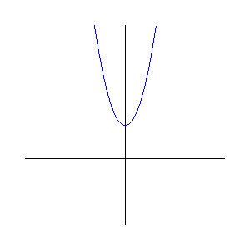

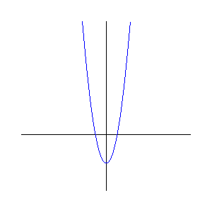

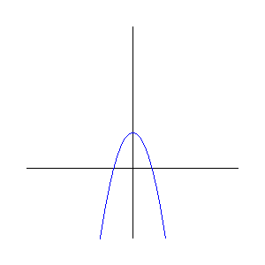

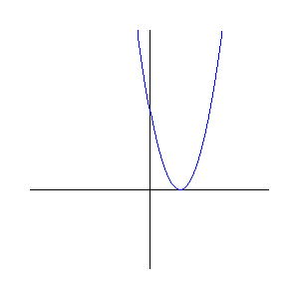

1. Name the five parent functions that we are studying.